

[Advanced Computational Neuroscience Network (ACNN)](http://www.NeuroscienceNetwork.org)

**Midwest Workshop on Big Neuroscience Data, Tools, Protocols & Services**

**Workshop Handbook**

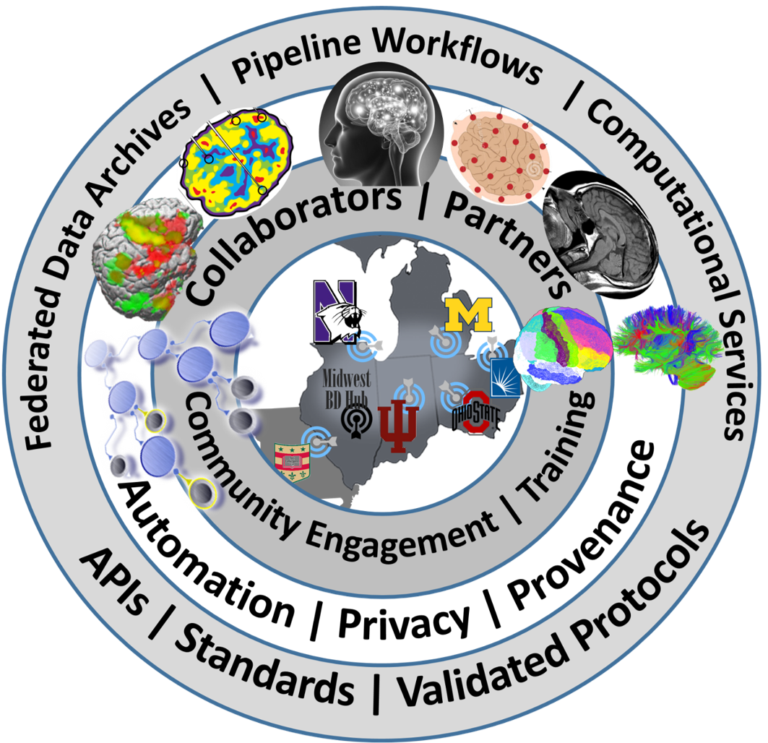

[**http://www.neurosciencenetwork.org/ACNN_Workshop_2016.html**](http://www.neurosciencenetwork.org/ACNN_Workshop_2016.html)

Contents

Overview 2

About the Workshop 3

Organizers 3

Goals 3

Contacts 3

Program 4

**Day 1 (Tue 9/20/16)** 4

**Day 2 (Wed 9/21/16)** 5

Working Groups 6

Unconference Breakout Sessions 7

Hands-on/Try-It-Now Demos 9

Shareable Resources 10

Workshop Registration including Trainee/Fellow Scholarship Application 11

Notes 12

Sponsors 13

Supplementary Materials 14

Post-conference Evaluation 15

Participants 17

Maps & Directions 18

**The Advanced Computational Neuroscience Network (ACNN) is partially supported by NSF grants**

[**1636840**](http://www.nsf.gov/awardsearch/showAward?AWD_ID=1636840)**,** [**1636846**](http://www.nsf.gov/awardsearch/showAward?AWD_ID=1636846)**,** [**1636893**](http://www.nsf.gov/awardsearch/showAward?AWD_ID=1636893)**,** [**1636850**](http://www.nsf.gov/awardsearch/showAward?AWD_ID=1636850)**, and** [**1550320**](http://www.nsf.gov/awardsearch/showAward?AWD_ID=1550320)**.**

## Overview

|  |  |
| --- | --- |
| What | An interactive Big Neuroscience Data Analytic Workshop |
| Where/Venue | Michigan League, University of Michigan, 911 N University Ave, Ann Arbor, MI 48109, Phone: (734) 764-0446, Web: <https://uunions.umich.edu/league> |
| Dates | September 20-21, 2016 |
| Accommodation | * **Michigan League**, University of Michigan, 911 N University Ave, Ann Arbor, MI 48109, Phone: (734) 764-0446, Web: <https://uunions.umich.edu/league> * The **Holiday Inn** Near the University of Michigan, 3600 Plymouth Road, Ann Arbor, MI 48105, 734-796-9800, Web: <http://www.hiannarbor.com> |
| Travel Scholarships | 60 Travel scholarships are available for Students, Postdocs, Fellows, and other Trainee on a first-come-first-serve bases |
| URL | [**www.NeuroscienceNetwork.org/ACNN_Workshop_2016.html**](http://www.NeuroscienceNetwork.org/ACNN_Workshop_2016.html) |

## About the Workshop

Organizers: A team of transdisciplinary investigators from the [Advanced Computational Neuroscience Network (ACNN)](http://www.NeuroscienceNetwork.org), including:

* University of Michigan: [Ivo Dinov](http://www.umich.edu/~dinov), [Rich Gonzales](http://www.rcgd.isr.umich.edu/people/gonzalez.html), [George Alter](http://www.icpsr.umich.edu/icpsrweb/content/shared/ICPSR/staff/alter.html)
* Indiana University: [Franco Pestilli](http://psych.indiana.edu/faculty/franpest.php), [Olaf Sporns](http://psych.indiana.edu/faculty/osporns.php), [Andrew Saykin](http://snri.medicine.iu.edu/people/primary-investigators/andrew-saykin-psy-d/)
* OSU: [Dhabaleswar Panda](http://web.cse.ohio-state.edu/~panda), [Khaled Hamidouche](https://web.cse.ohio-state.edu/~hamidouc), [Xiaoyi Lu](http://web.cse.ohio-state.edu/~luxi), [Hari Subramoni](http://web.cse.ohio-state.edu/~subramon)
* CWRU: [Satya Sahoo](https://sites.google.com/a/case.edu/bmhinformaticsgroup/about-us)
* Washington University: [Daniel Marcus](https://www.mir.wustl.edu/research/research-support-facilities/neuroimaging-informatics-analysis-center-niac/our-staff/niac-staff-dan-marcus), and Northwestern University: [Lei Wang](http://www.nuin.northwestern.edu/members-2/lwang)

Goals: Students, trainees, fellows, junior investigators, and outside researchers in Midwest academic institutions and industry partners are invited to attend and actively participate in this workshop. Expected workshop outcomes include (1) building an active Midwest Neuroscience Network Community, (2) open-sharing of data-intense challenges, datasets, research projects, expertise, software, services, protocols, resources, learning modules, and (3) productive discussions of joint (multi-institutional) grants, training opportunities, publications, research projects. The workshop success will be measured by assessing the community involvement (early registration, active workshop participation, post-workshop activities and interactions), website analytics (geographic locations of income traffic, counts, frequencies, and intensity of web-site utilization ([www.NeuroscienceNetwork.org](http://www.NeuroscienceNetwork.org)), and evidence of collaborations on development of software tools, services, learning materials, end-to-end pipeline workflows.

### Contacts

Administrative: Alison Martin ([aalison@med.umich.edu](mailto:aalison@med.umich.edu)) or Programmatic: Ivo Dinov [](http://www.socr.umich.edu/img/Dinov_Email.png).

## Program

|  |  |  |
| --- | --- | --- |
| Time | **Day 1 (Tue 9/20/16)** | |
| **Sessions** | **Details** |
| 8-9 AM | Registration | Onsite registration, nametags, booklets, breakfast, coffee, networking |
| 9:00-9:45 | Workshop Overview ACNN Background, Scope Organization/Format | 1. Workshop Overview (Ivo Dinov), 15 min 2. Midwest Big Data Hub Health Sciences (Brian Athey), 15 min 3. Advanced Computational Neuroscience Network (Rich Gonzalez), 15-min |
| 9:45-12:15 | Big Neuroscience Data, Gaps/Barriers, Analytical Methods, Available Resources, Distributed Services, and Opportunities | 1. Indiana Computational Neuroimaging Research (Franco Pestilli) 20 min 2. OSU Network Based Computing (Dhabaleswar Panda, Khaled Hamidouche, Xiaoyi Lu, Hari Subramoni) 20 min 3. CWRU Biomedical and Healthcare Informatics (Satya Sahoo) 20 min   **BREAK 10 min**   1. HumanConnectome: Neuroimaging Informatics and Analysis Center (Daniel Marcus) 20 min 2. Northwestern Neuroimaging and Applied Computational Anatomy (Lei Wang) 20 min 3. Michigan Institute for Data Science (Ivo Dinov), 20 min |
| 12:15-1:15 | **Lunch Break** |  |
| 1:15-3:15 | Unconference Breakout Sessions (4 consecutive slots of 30-min each). Participants are encouraged to lead breakouts and mix with others. | Informal self-organized sessions (30-minutes each), round-robin rotations  Web-form: <https://goo.gl/bKWNvi> |
| 3:15-3:30 | **Break** |  |
| 3:30-4:30 | Breakout sessions reports  Web-form: <https://goo.gl/bKWNvi> | Analytics Pipelines Tools/Services |
| Challenges |
| Known Solutions |
| Predictive analytics - methods, tools, protocols, workflows |
| Provenance (data, protocols, results, reproducibility or research findings) |
| Computational Neuroscience Methods |
| Case-studies, data archives, Cloud Services |
| 4:30-5:30 | Posters/Demos | Applications (brain mapping, imaging-genetics neurodegeneration)  Web-form: <https://goo.gl/bKWNvi> |
| 6:00-8:00 PM | **Dinner** | Social Networking |

|  |  |  |
| --- | --- | --- |
| Time | **Day 2 (Wed 9/21/16)** | |
| **Sessions** | **Details** |
| 8:00-8:30 AM | Registration | Onsite registration, nametags, booklets, breakfast, coffee, networking |
| 8:30-11:00 | Core Big Neuroscience Infrastructure | 1. Neuroscience Information Framework: A Cooperative And Collaborative Information, Resource, and Data Discovery Infrastructure (Jeff Grethe) 25 min 2. Indiana Computational Neuroimaging Research (Franco Pestilli) 25 min 3. OSU Network Based Computing (Dhabaleswar Panda, Khaled Hamidouche, Xiaoyi Lu, Hari Subramoni) 25 min   **BREAK 10-min**   1. CWRU Biomedical and Healthcare Informatics (Satya Sahoo) 25 min 2. Predictive Big Data Analytics (Ivo Dinov), 25 min |
| 11:00-11:10 | **Break** |  |
| 11:10-12:10 | Lightning Talks | 3-5 min Rapid-Fire talks from the Midwest Big Data Community  Web-form: <https://goo.gl/bKWNvi> |
| 12:10-1:10 | **Lunch Break** |  |
| 1:10-2:40 | Unconference Breakout Sessions (3 consecutive slots of 30-min each). Participants are encouraged to lead breakouts and mix with others. | Informal self-organized sessions (30-minutes each), round-robin rotations: Brain structure, Function, Diffusion, Physiology; File Formats; Pipeline workflow Environments; Cloud Services: JIRA, GitHub, Trello, AWS, MapReduce, Hadoop; Driving Biomedical/Healthcare Challenges, etc.  Web-form: <https://goo.gl/bKWNvi> |
| 2:40-2:50 | **Break** |  |
| 2:50-3:30 | Breakout sessions reports | Analytics Pipelines Tools/Services |
| Challenges |
| Known Solutions |
| Predictive analytics - methods, tools, protocols, workflows |
| Provenance (data, protocols, results, reproducibility or research findings) |
| Computational Neuroscience Methods |
| Case-studies, data archives, Cloud Services |
| 3:30-4:00 | Live Demos  Try-It-Now | Applications (brain mapping, imaging-genetics neurodegeneration) |
| 4:00 PM | **Conclusions** | Workshop Evaluation (<http://goo.gl/forms/qSI6PGiN4PfTs6Fg1>). Collaborations, joint papers, extramural grant opportunities, Shareable resources, Available Webapps, APIs, workflows |
|  | Post-conference Report | Generate a Report (due 1 month after workshop) |

## Working Groups

Participants are encouraged to self-organize working groups that focus on specific Big Neuroscience Data challenges, resource, translational education activities, and collaborative opportunities. These working groups (WG) may be initiated organically, coalesce at the breakout sessions, or start informally at social networking periods (e.g., breaks).

## Unconference Breakout Sessions

Use the Breakout Session Board to **\*review\*** and **\*propose\*** discussion topics at the appropriate times. Be prepared to take notes at your break out session and report on outcomes/achievements/plans/actions that came out of the discussions.

Web-form: <https://goo.gl/bKWNvi>

|  |  |  |  |  |  |  |  |  |  |
| --- | --- | --- | --- | --- | --- | --- | --- | --- | --- |
| *Unconference Breakout Sessions (consecutive slots of 30-min each). Participants are encouraged to lead breakouts and mix with others. These are Informal self-organized sessions. Participants can rotated through breakouts* | | | | | | | | | |
| Day 1: 1:15-3:15 PM | | | | | **Notes** | **Day 2: 1:10-2:40** | | | |
| Proposed  Topics | 1:15-1:45 | 1:45-2:15 | 2:15-2:45 | 2:45-3:15 |  | **Proposed**  **Topics** | 1:10-1:40 | 1:40-2:10 | 2:10-2:40 |
| Enter Topic1 | *(tally interested attendees)* | … | … | … |  | **Enter**  **Topic1** | *(tally interested attendees)* | … | … |
| … | ... | … | … | … |  | **…** | ... | … | … |
| … | ... | … | … | … |  | **…** | ... | … | … |
| … | ... | … | … | … |  | **…** | ... | … | … |
| … | ... | … | … | … |  | **…** | ... | … | … |
| … | ... | … | … | … |  | **…** | ... | … | … |
| Breakout Session Reports: 3:20-4:20   * Analytics Pipelines * Tools/Services * Challenges * Known Solutions * Predictive analytics - methods, tools, protocols, workflows * Provenance (data, protocols, results, reproducibility or research findings) * Computational Neuroscience Methods * Case-studies, data archives * Cloud Services * Other | | | | |  | **Breakout Session Reports: 2:30-3:00**   * Analytics Pipelines * Tools/Services * Challenges * Known Solutions * Predictive analytics - methods, tools, protocols, workflows * Provenance (data, protocols, results, reproducibility or research findings) * Computational Neuroscience Methods * Case-studies, data archives * Cloud Services * Other | | | |

**Notes about Self-Organizing Unconference Sessions**:

1. **Before the Breakout Unconference Session** 
   1. Use the blank Session Board to add a note (piece of paper) stating the topic of the session and a short description. It’s fine to start conversations, answer questions, present data challenges, identify specific needs, projects, etc.
   2. This workshop follows Open Space/Open Science Principles
2. **During the Breakout Unconference Session**
   1. Announce your intended unconference session early on the Board
   2. At the end, all groups will share ideas, outcomes, results, knowledge gained at each session
   3. The basic idea is to provide a platform for networking, support, collaborations and hear about what others are doing impromptu
   4. Any participant is welcome to any breakout session (rotations are allowed)
   5. Each session should have a short Name describing the topic or theme
   6. Start a session with very brief introductions (“what are your interests/problems”, 3 hashtags about yourself, institution, etc.)
3. **Rules**
   1. Different people may post similar sessions, consider if it makes sense to merge the sessions before you offer an alternative session (may also offer a subsequent session on the same topic)
   2. Session can be moved on the agenda wall, but try to minimize stochasticity
   3. You can only move/shift a session you have proposed, but you can “lobby” others and coordinate
   4. After Breakout sessions, we’ll share highlights, insights and next steps.
   5. You can use social-media, blogging, wikis, etc. to track session activities, before, during and after the breakout
   6. All participants can come forward and convene sessions
   7. All participants should watch the Session Board throughout the workshop
   8. The 30-min limits for breakout sessions are suggesting, not set in stone, however, all attendees are encouraged to move about sessions during the breakout period
   9. Try to give everyone a change to actively participate (avoid discussion domination)

## Hands-on/Try-It-Now Demos

During the conference, participants may sign in to present and showcase hands-on their group’s challenges, case-studies, datasets, software tools, services, computational infrastructure, and other materials and resources. Avoid sales pitches and infomercials. Open-science resources should be emphasized.

Web-form: <https://goo.gl/bKWNvi>

|  |  |  |  |
| --- | --- | --- | --- |
| Day 2: 3:30-4:00 | | | |
| Demos | **3:30-3:40** | **3:40-3:50** | **3:50-4:00** |
| Demo 1 Description | *(tally interested attendees)* | … | … |
| … | ... | … | … |
| … | ... | … | … |
| … | ... | … | … |

Each demo-presenter is encouraged to draft a **1-page PDF handout** that can be submitted to the organizers (email to [aalison@med.umich.edu](mailto:aalison@med.umich.edu)) and handed out to attendees during the conference. See the Shareable Resources section. The handout should include the following components:

* Demo Title: <text>
* Description: <text>
* Problem Solved: <text>
* Approach: <text>
* URL Download: <url>
* URL Documentation: <url>
* License: <text/url>
* Institution: <name>
* Developers: <lists of names or text>
* Email Contact: <email>
* Version: <text>

## [Shareable Resources](https://docs.google.com/forms/d/1nCnxtbvp-V9mQOSbfzhHBW17LlwoyzfntadvqBRYKsA)

This [web-form](https://docs.google.com/forms/d/1nCnxtbvp-V9mQOSbfzhHBW17LlwoyzfntadvqBRYKsA) (<https://goo.gl/okbqF1>) can be used to submit items for inclusion in the sharable resources. Examples (not an exclusive list) of appropriate resources that may be suggested include:

* Highly scalable APIs
* Relevant publications
* Cloud-services
* Computational Resources
* Algorithms, methods, techniques
* Education and Training Opportunities

You can see a [real-time summary of the results](https://docs.google.com/forms/d/1nCnxtbvp-V9mQOSbfzhHBW17LlwoyzfntadvqBRYKsA/viewanalytics?pli=1&usp=form_confirm) and a [tabular representation of previously submitted resource meta-data](https://docs.google.com/spreadsheets/d/1YQPGSazxSzmTAsIIIyUXzbw0ZTbs3pR9pDUqbr2t-_c/edit?usp=sharing).

## [Workshop Registration including Trainee/Fellow Scholarship Application](https://docs.google.com/forms/d/1g-9a5-VXOGHJ7aQAs6sofzwS5D3XCuIx5DDTO4WEwkQ)

Space is limited. Complete and submit this [registration form](https://docs.google.com/forms/d/1g-9a5-VXOGHJ7aQAs6sofzwS5D3XCuIx5DDTO4WEwkQ) early to register to attend the workshop. Over 60 travel/accommodation scholarships are available for Students, Postdocs, Fellows, and other Trainee on a first-come-first-serve bases. Please complete this web-form early.

**Assistance/Questions**

Email: Alison Martin ([aalison@med.umich.edu](mailto:aalison@med.umich.edu))

## Notes

## Sponsors

The National Science Foundation, <http://www.nsf.gov/news/news_summ.jsp?cntn_id=136784>



Midwest Big Data Hub, <http://MidwestBigDataHub.org>

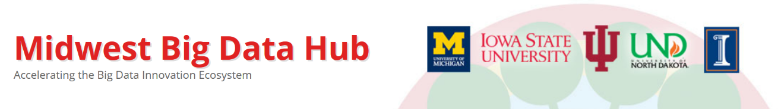

The Michigan Institute for Data Science (MIDAS)**,** <http://midas.umich.edu>



The Indiana Imaging Research Facility (IRF), <https://www.indiana.edu/~irf/home>

Imaging Research Facility

Indiana University Bloomington



OSU Network Based Computing**,** <http://nowlab.cse.ohio-state.edu>

|  |  |  |
| --- | --- | --- |
| HiBD | **High-performance Big Data (HiBD)**  [**Network-Based Computing Laboratory**](http://nowlab.cse.ohio-state.edu/) | OSU Logo |

CWRU Biomedical and Healthcare Informatics**,** <https://goo.gl/l19s07>



Michigan Nutrition Obesity Research Center (MNORC) <http://mmoc.med.umich.edu>



## Supplementary Materials

**Shareable Resources**

Please submit resources that are relevant and synergistic to the efforts of the [Advanced Computational Neuroscience Network (ACNN)](http://neurosciencenetwork.org). These resources should be validated and have direct neuroscience applications, be freely available/accessible and interoperate with other resources.

* Denotes required meta-data.

1. Resource Name *: <text>
2. Resource Type * (Multiple item selection)
   * Highly scalable APIs
   * Relevant publications
   * Cloud-services
   * Computational Resources
   * Algorithms, methods, techniques
   * Education and Training Opportunities
   * Other: __________________________
3. Resource URL *: <url>
4. Resource License: <text/url>
5. Description: <text area>
6. Institution: <name>
7. Developers: <lists of names or text>
8. Email Contact: <email>
9. Version: <text>

## Post-conference Evaluation

After the completion of the workshop, all attendees are asked to anonymously complete the following workshop evaluation form and submit it via regular mail or electronically by completing the web-form (<http://goo.gl/forms/qSI6PGiN4PfTs6Fg1>). The aggregate results of this evaluation will be used to improve, enhance and expand future ACNN training events, activities and bootcamps. The sponsors will also be informed of the summative workshop evaluation results.

1. **Attendee Demographics:**

1. **Describe your background, expertise and interests in Big Neuroscience Data and Predictive Analytics**

* + 1. **What is your current role** <drop-down, select one or more items>

Undergraduate student, graduate/professional students, postdoc, scholar/fellow, faculty (rank), developer, researcher/scientist, administrator, government official, industry partner

* + 1. **What attracted you to participate in the 2016 ANCC Workshop**?

**B. Workshop Outcomes.** The blended conference/unconference sessions of the workshop were designed to allow diverse groups of investigators to showcase their resources, identify barriers, suggest open-problems and call for action/activity on specific challenges. Please rate each one of the following:

**Note**: “1” represents the lowest score; a “5” represents the highest score. Please make comments.

**The workshop sessions helped me to do the following:**

|  |  |  |  |  |  |  |
| --- | --- | --- | --- | --- | --- | --- |
|  | 1  (low) | 2 | 3  (medium) | 4 | 5  (high) | Comments |
| 1. Learn Big Data Advances, Challenges and Opportunities |  |  |  |  |  |  |
| 2. Learn strategies for efficient Big Data management |  |  |  |  |  |  |
| 3. Learn the practice of Big Data Analytics |  |  |  |  |  |  |
| 4. Learn about computational Neuroscience applications of Big Data |  |  |  |  |  |  |
| 5. Professional networking |  |  |  |  |  |  |

1. **Workshop Sessions.** Rate the following on their usefulness in helping you with Big Data science learning, predictive analytic practicing, and translational neuroscientific applications.

Use a scale of 1-5, with 1 = not useful and 5 = very useful. Please make comments.

|  |  |  |  |  |  |  |
| --- | --- | --- | --- | --- | --- | --- |
|  | 1  (low) | 2 | 3  (medium) | 4 | 5  (high) | Comments |
| 1. Sessions allowed for interactive exchanges |  |  |  |  |  |  |
| 2. Usefulness of the presented data, resources, tools and services |  |  |  |  |  |  |
| 3. TBD |  |  |  |  |  |  |
| 4. TBD |  |  |  |  |  |  |
| 5. TBD |  |  |  |  |  |  |

1. **Workshop Arrangements.** Rate the following on a scale of 1-5, with 1 = Disagree and 5 = Agree.

|  |  |  |  |  |  |  |
| --- | --- | --- | --- | --- | --- | --- |
|  | 1  (disagree) | 2 | 3  (neutral) | 4 | 5  (agree) | Comments |
| 1. Workshop facilities were satisfactory |  |  |  |  |  |  |
| 2. Workshop facilitators were effective in communicating ideas and issues |  |  |  |  |  |  |
| 3. Workshop facilitators were effective in organizing sessions so that I was actively involved |  |  |  |  |  |  |
| 4. A collaborative and helpful tone was established during the session |  |  |  |  |  |  |
| 5. Overall workshop logistics were well-planned and organized |  |  |  |  |  |  |

**D. Other Feedback**

* List a couple of BIG IDEAS about Big Neuroscience Data that came to you during this workshop?
* In what ways could this workshop be improved?
* What workshop outcomes would help you advance your research, development, service and teaching?
* Open-ended comments

## Participants

List of Workshop presenters and participants.

| Name | Affiliation | Contact (URL/Email/Phone) |
| --- | --- | --- |
| Ivo Dinov | University of Michigan | <http://www.umich.edu/~dinov> |
| Rich Gonzalez | University of Michigan | <http://www.rcgd.isr.umich.edu/people/gonzalez.html> |
| Franco Pestilli | Indiana University | <http://psych.indiana.edu/faculty/franpest.php> |
| Olaf Sporns | Indiana University | <http://psych.indiana.edu/faculty/osporns.php> |
| Andrew Saykin | Indiana University | <http://goo.gl/ycQuk2> |
| Khaled Hamidouche | Ohio State University | <https://web.cse.ohio-state.edu/~hamidouc> |
| Xiaoyi Lu | Ohio State University | <http://web.cse.ohio-state.edu/~luxi> |
| Hari Subramoni | Ohio State University | <http://web.cse.ohio-state.edu/~subramon> |
| Satya Sahoo | CWRU | <https://goo.gl/dfa6wZ> |
| Daniel Marcus | Washington University | <https://goo.gl/9cH9Na> |
| Lei Wang | Northwestern U | <http://www.nuin.northwestern.edu/members-2/lwang> |
| … |  |  |
|  |  |  |
| A complete list of participants will be available on the Workshop website at the conclusion of the conference | | |

## Maps & Directions

**Parking**: <https://campusinfo.umich.edu/article/parking>

Parking in Ann Arbor and on campus is often limited. However, there are many structures and some street parking around campus.  For more details and maps of parking areas please visit [Ann Arbor Downtown Development Authority](http://www.a2dda.org/transportation/), [arborweb](http://arborweb.com/cg/t0023.html), and [UM Parking & Transport Services](https://pts.umich.edu/parking/).

**Parking Rates**  
Most structures have a rate of $1.10/hr. Some structures are $1.40/hr. A list of rates for every structure is available on the [Downtown Development Authority](http://www.a2dda.org/transportation/) website. For a list of rates for on campus structures, check out the [Visitor Parking](http://pts.umich.edu/parking/visitors.php) link on the Parking and Transportation Services website.

**Free Parking**  
On Central Campus, free parking is available during these times:  
Monday-Saturday: after 6:00pm  
Sunday: All Day

**Main Landmarks**

* **Holiday Inn**, 3600 Plymouth Road, Ann Arbor, MI 48105
* **Michigan League**, 911 North University Avenue, Ann Arbor, MI 48109
* **Graduate Ann Arbor**, 615 East Huron Street, Ann Arbor, MI 48104
* **Bell Tower Hotel**, 300 South Thayer Street, Ann Arbor, MI 48104



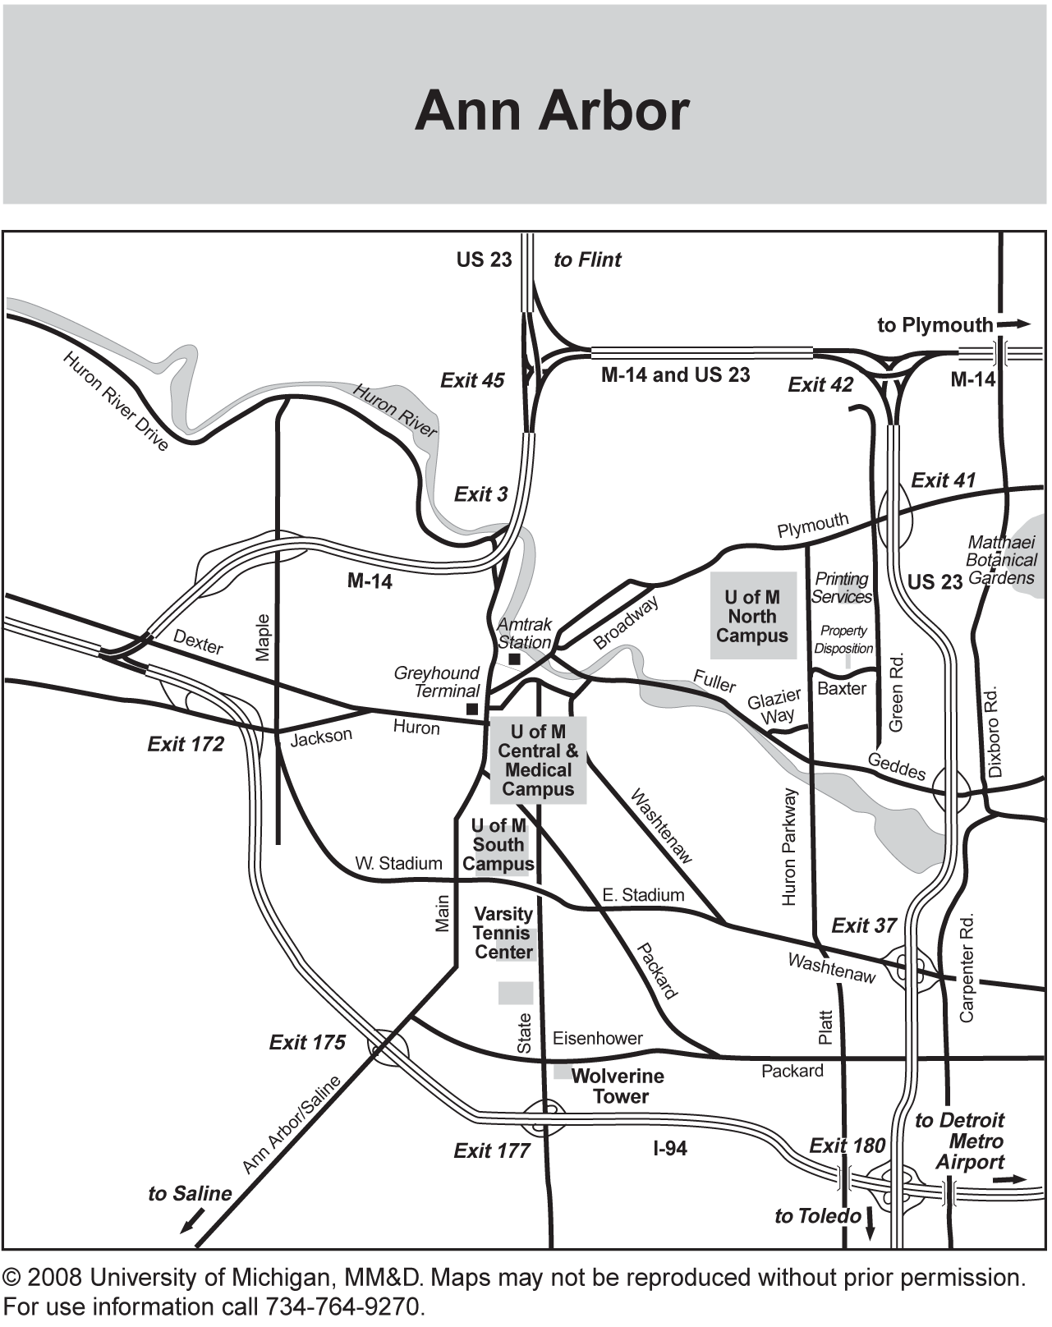

**University of Michigan Central Campus**





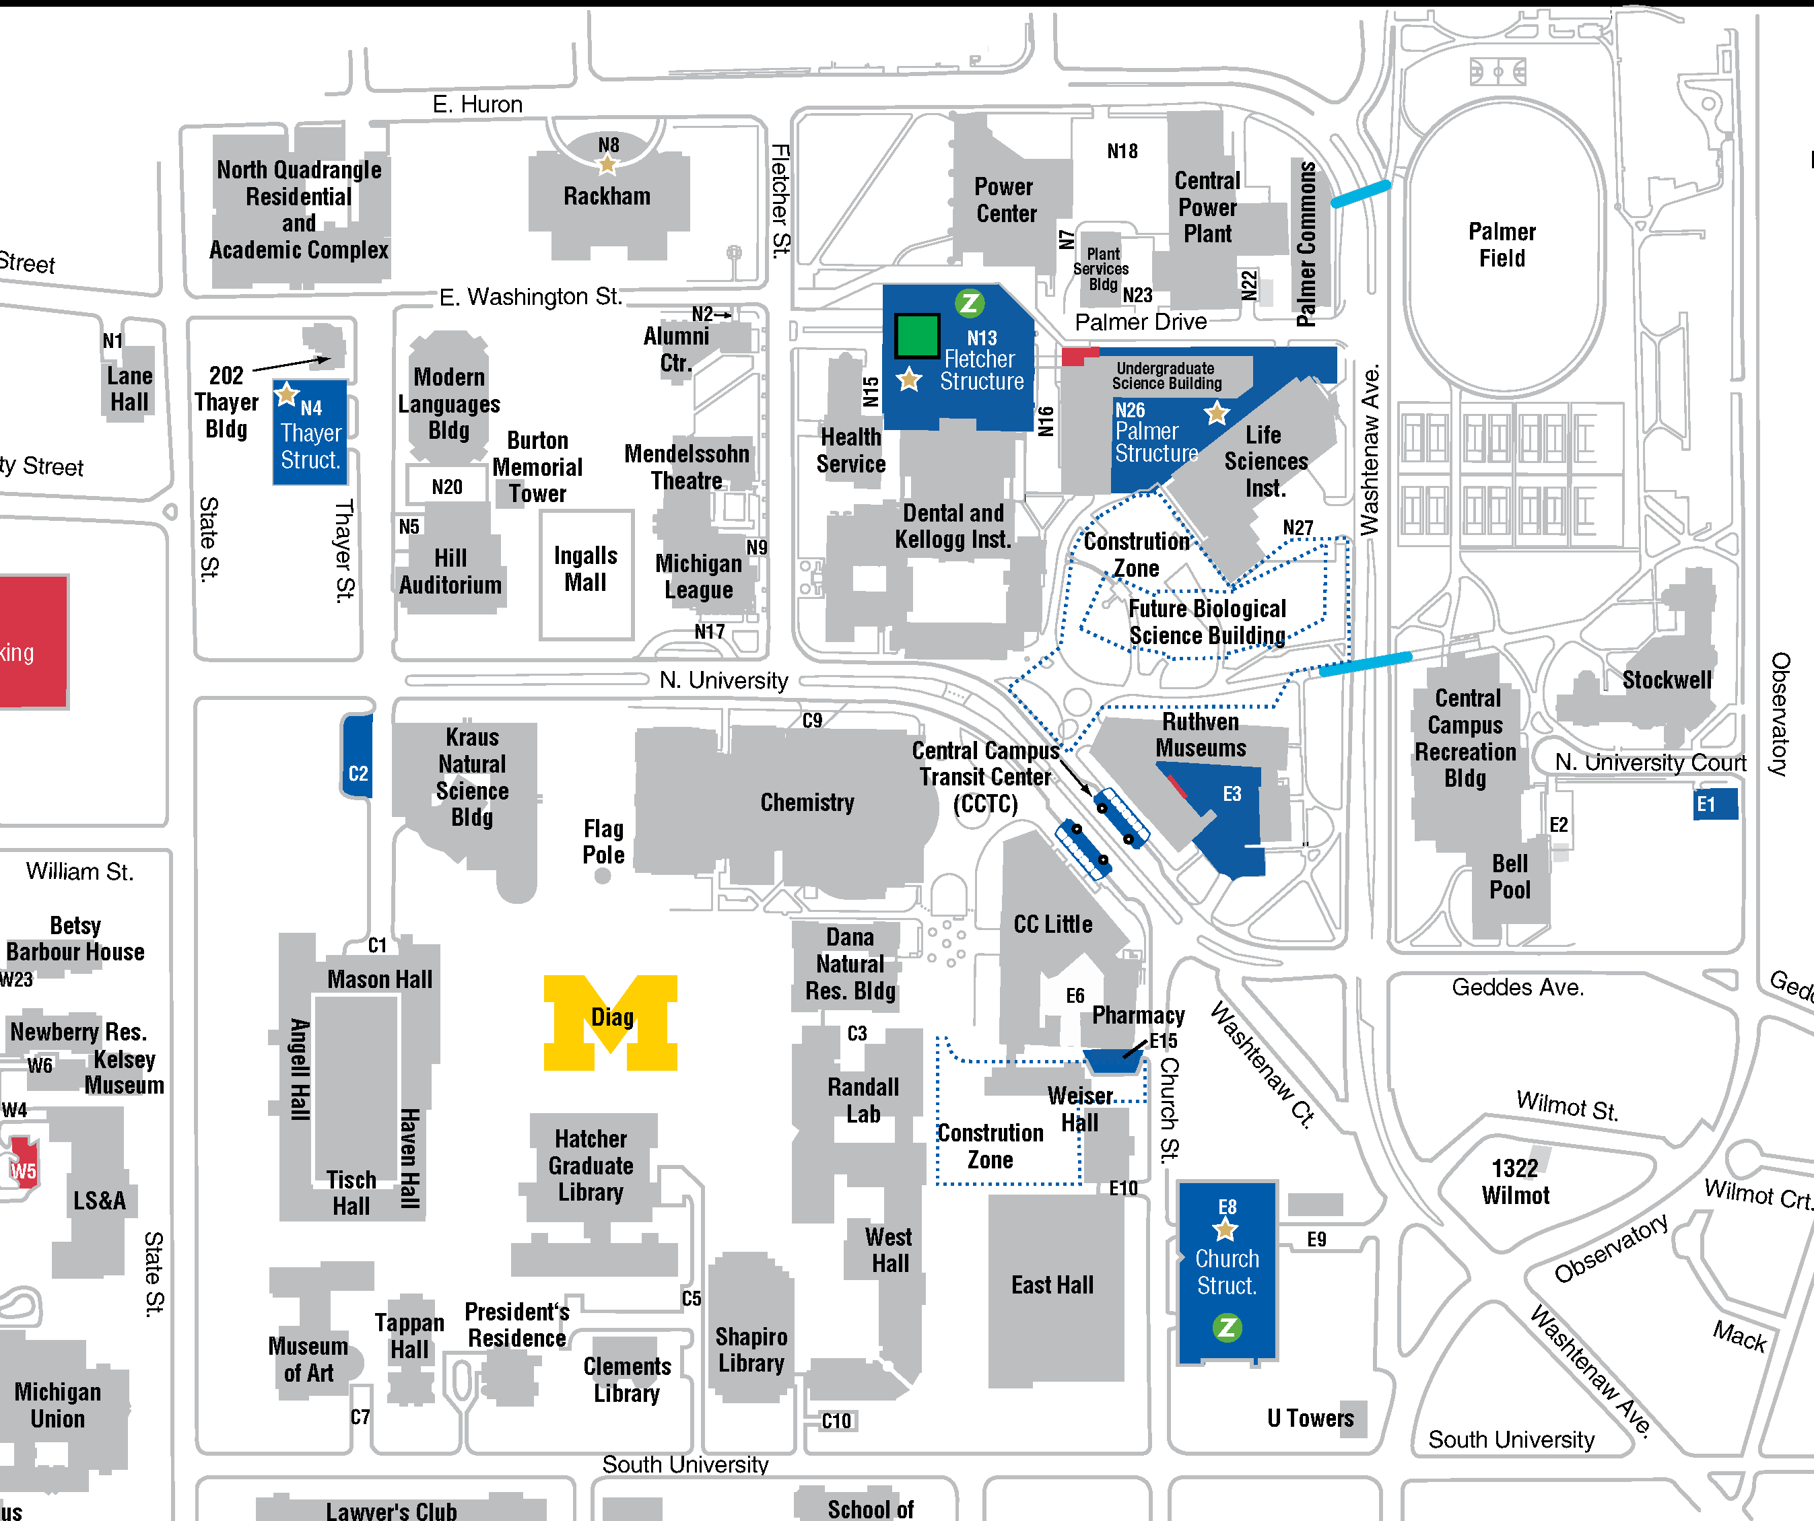

[Advanced Computational Neuroscience Network (ACNN)](http://www.NeuroscienceNetwork.org)

**Midwest Workshop on Big Neuroscience Data, Tools, Protocols & Services**

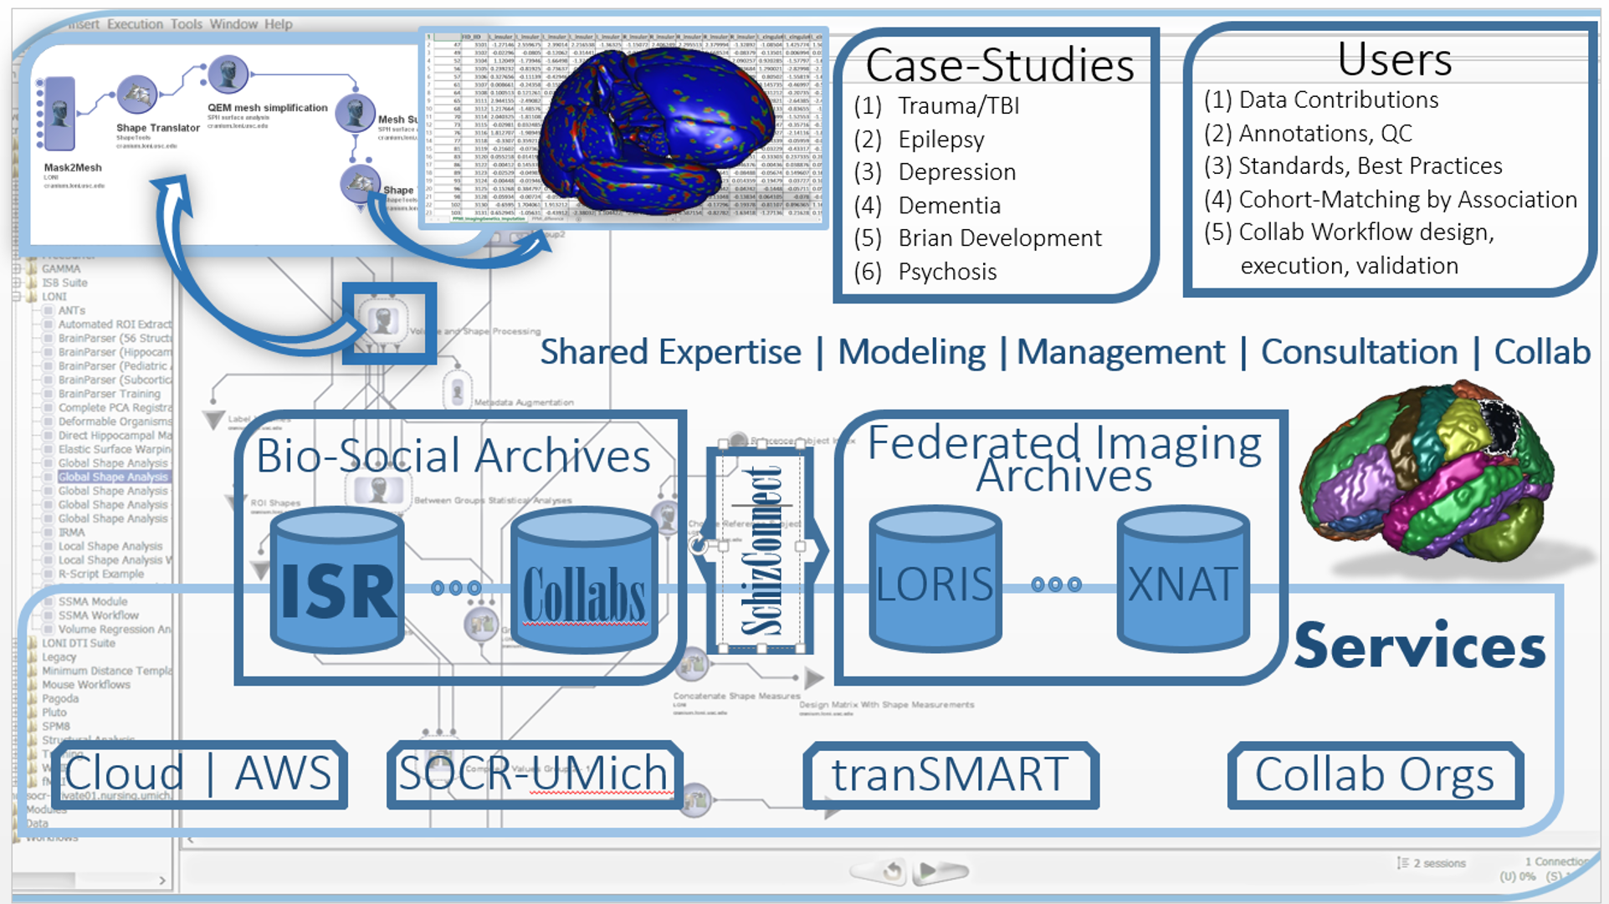



<http://www.NeuroscienceNetwork.org/ACNN_Workshop_2016.html>

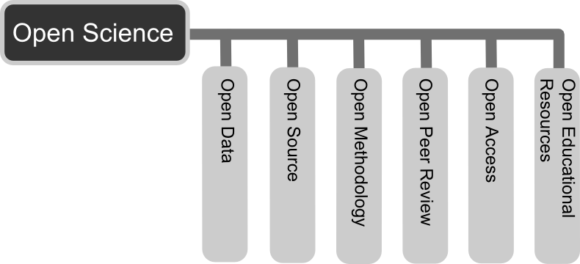

This book is produced by SOCR Publications (<http://SOCR.umich.edu>). All materials are CC-BY licensed

